Lab Objective

Configuring DFS Replication

**Lab Procedures**

**1.** On Server01, create a **C:\Share3** folder. Share the folder as Share3. Assign Allow Full ControlShare permissions to Everyone.

**2.** On Server02, create a **C:\Share3** folder. Share the folder as Share3. Assign Allow Full ControlShare permissions to Everyone.

**3.** On Server01 DFS Management console, right-click Replication and select New Replication Group.

**4.** On the Replication Group Type page, click Next.

**5.** On the Name and Domain page, type **Rep1** in the Name of replication group text box. Click the Next button.

**6.** On the Replication Group Members page, click the Add button.

**7.** When the Select Computers dialog box opens, type **Server01** in the Enter the object names to select text box and click OK. If it asks you to enter a network password, specify **Contoso\Administrator** and password of **Password01**.

**8.** Click Add and add Server02.

**9.** Take a screen shot of the New Replication Group Members page by pressing Alt+Prt Scr and then paste it into your Lab04_worksheet file in the page provided by pressing Ctrl+V.

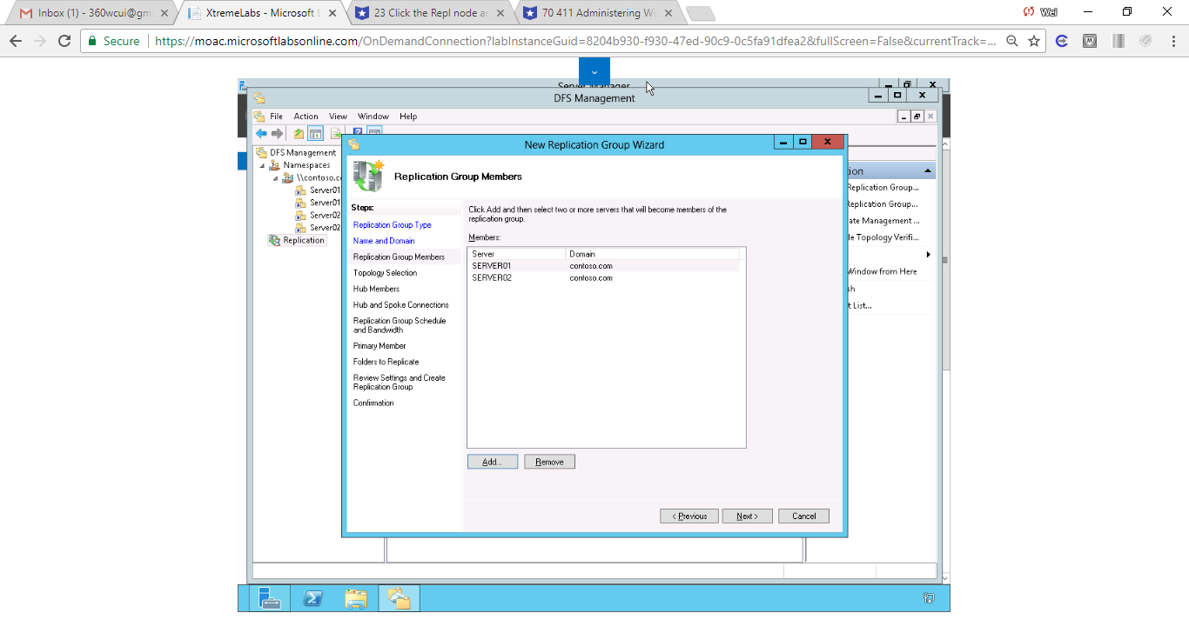

**10.** Back on the Replication Group Members page, click Next.

**11.** On the Topology Selection page (as shown in Figure 4-5), click Next.

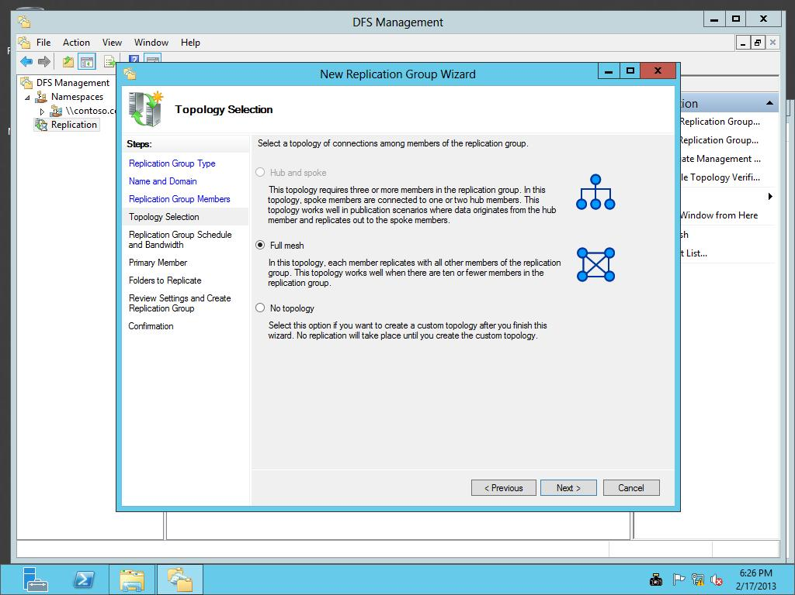

Figure 4-5

Selecting the DFS topology

**12.** On the *Replication Group Schedule and Bandwidth* page, click Next.

**13.** On the Primary Member page, select Server01 as the Primary member. Click Next.

**14.** On the Folders to Replicate page, click Add.

**15.** When the Add Folder to Replicate dialog box opens, type **C:\Share3** in the Local path of folder to replicate text box and click OK.

**16.** Back on the Folders to Replicate page (as shown in Figure 4-6), click Next.

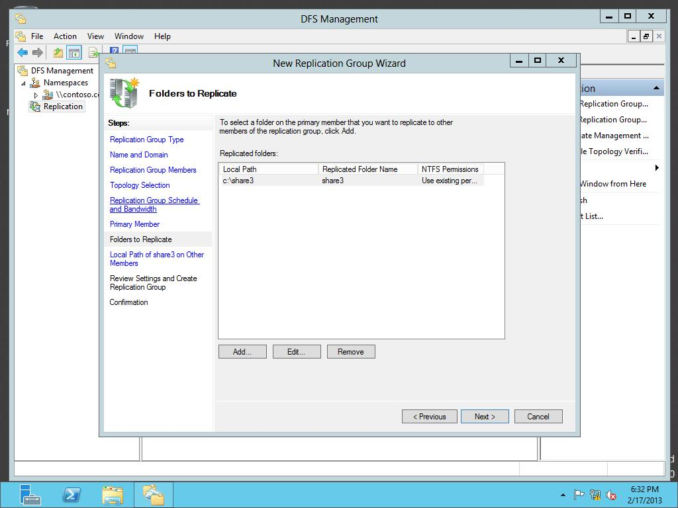

Figure 4-6

Adding folders to replicate

**17.** On the Local Path of Share3 on Other Members page, with Server02, click Edit.

**18.** Click Enabled and type **C:\Share3** in the Local path of folder text box as shown in Figure 4-7. Click OK to close the Edit dialog box.

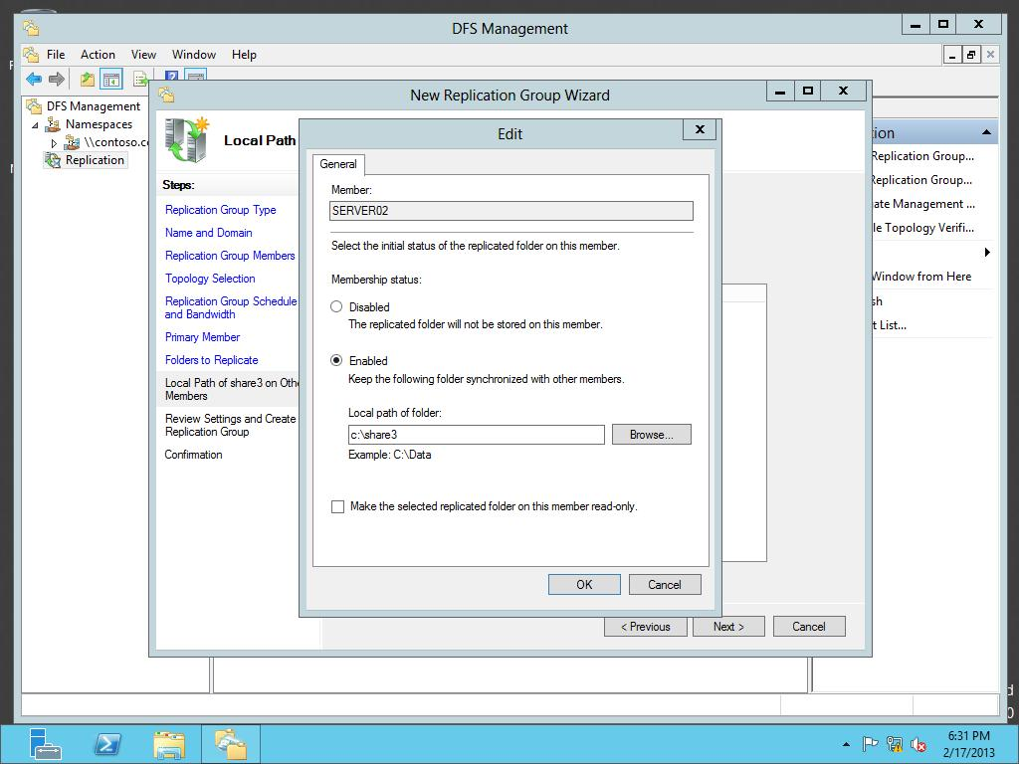

Figure 4-7

Accessing a namespace

**19.** Back on the Local Path of Share3 on Other Members page, click Next.

**20.** On the *Review Settings and Create Replication Group* page, click Create.

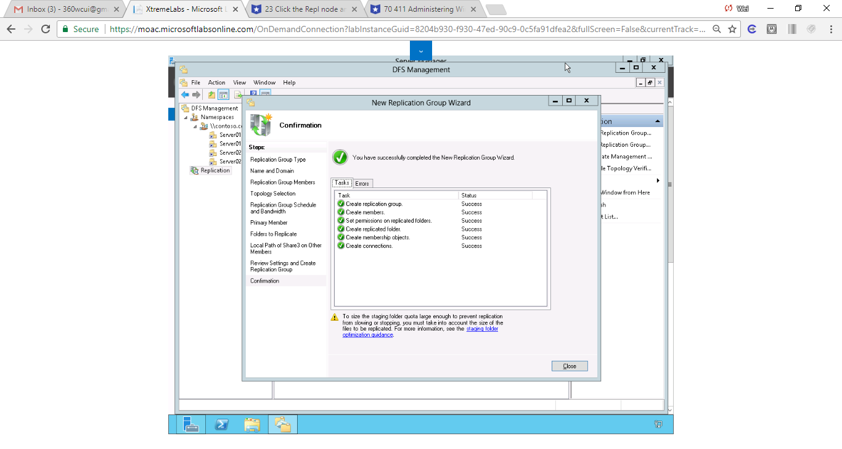

Figure Replication group has been created

**21.** When the replication group has been created, click Close.

**22.** If you get a Replication Delay message, click OK.

**23.** Click the Repl node and take a screen shot of the DFS Replication by pressing Alt+Prt Scr and then paste it into your Lab04_worksheet file in the page provided by pressing Ctrl+V.

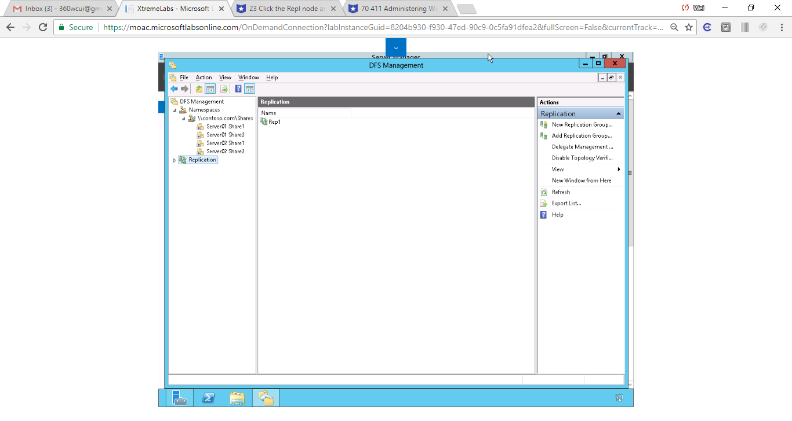

**24.** On Server01, open the C:\Share3 folder.

**25.** Right-click the opened folder, click New and click Text Document. Name the document **Doc1.txt**.

**26.** Open the Doc1.txt file and type your name. Save and close the text document.

**27.** On Server02, open the C:\Share3 folder and verify that the Doc1 has replicated to Server02. It may take a minute or two to replicate.

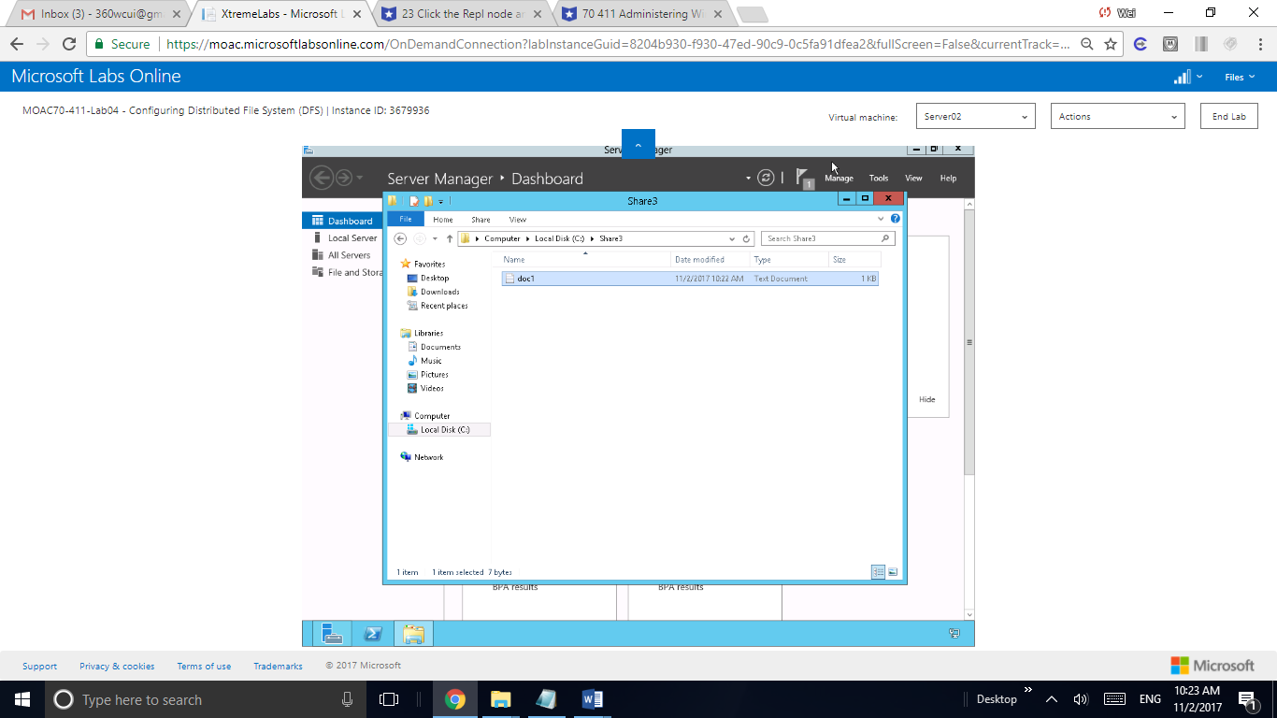

Figure The file has been successfully replicated on Server02

**Lab Summary**

During this exercise, I configured two folders, each on a different server. Configured DFS to replicate the content of one folder to the other server.

Mindset Question: You have a project folder that must be available in New York and Paris. Some of these files take some time to open over a slow WAN link, because of their size. What can you do to help alleviate this?

My answer to Mindset Questionn is to have two servers, one in New York, the other in Paris. Setup DFS replication.

1. In Exercise 4.3, what topology is used to have files replicate from one member to all other DFS members?

DFS Relication